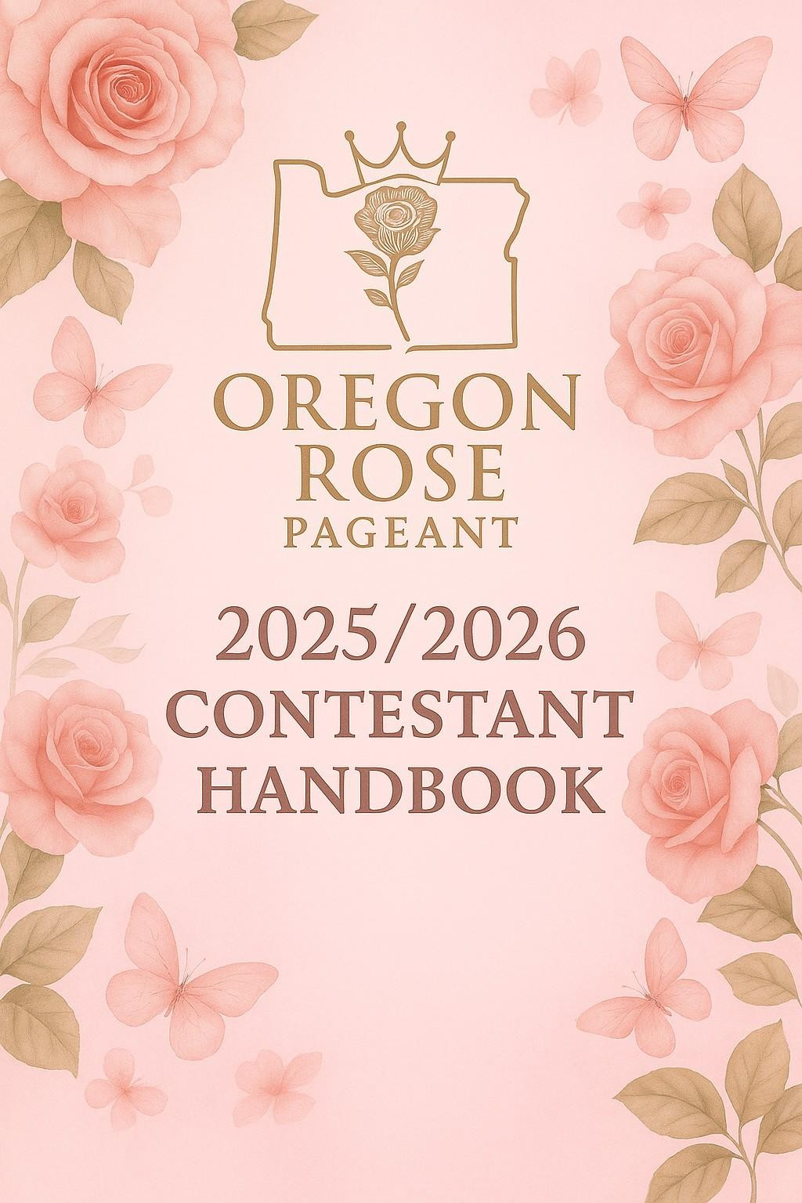
OREGON ROSE PAGEANT LLC
2025/2026 CONTESTANT HANDBOOK
Produced and directed by Oregon Rose Pageants LLC www.OregonRosePageant.com
Director.christina@oregonrosepageant.com
All rights reserved. This handbook may not be reproduced or shared without permission from Oregon Rose Pageants LLC.

TABLE OF CONTENTS
- Who We Are
- Contestant Divisions
- Required Paperwork and Photos
- Areas of competition
- Optional Program Ads
- Wardrobe Guidelines
- Judging Criteria
- Awards and Titles
- Entry Fees
- If You Win
- Pageant Weekend Information
- Rules & Regulations
- Code of Conduct & Expectations
- Hair & Makeup Guidelines
- Tentative Schedule

1. WHO WE ARE
The Oregon Rose Pageant is more than a beauty competition, it's a platform for young women and girls to grow in confidence, poise, and community engagement. We encourage contestants to shine as role models, leaders, and advocates.
Our mission is to uplift and empower contestants through elegance, self-expression, and community service. Every contestant becomes a part of the Oregon Rose sisterhood, a family of compassionate and ambitious individuals.

2. CONTESTANT DIVISIONS
- Tiny Miss Oregon Rose (Ages 3–6)
- Little Miss Oregon Rose (Ages 7–9)
- Junior Miss Oregon Rose (Ages 10–12)
- Teen Miss Oregon Rose (Ages 13–16)
- Miss Oregon Rose (Ages 17–24)
- Ms. Oregon Rose (Ages 25+)
- Mrs. Oregon Rose (Ages 18+, must be married)

3. REQUIRED PAPERWORK & PHOTOS
Each contestant must submit the following by the assigned deadline:
- Contestant Application
- Official 5x7 headshot (high resolution, 300dpi, no crown/hat)
- Community Service Summary
Forms and instructions will be sent via email upon registration. Please ensure all paperwork is submitted on time to guarantee participation and inclusion in the program book.
4. Areas of Competition:
- Formal Wear / Pageant Walk
- Interview
- Fun Fashion
- Community Service (A minimum of 5 hours is required — more is encouraged!)
- On-Stage Question

5. OPTIONAL PROGRAM ADS
Support your pageant journey by selling or purchasing ads for the official program book:
- Full-Page Ad: $500
- Half-Page Ad: $275
- Quarter-Page Ad: $100
Ad specs:
- Page Size: 8.5" x 11"
- Image Area: 7.5" x 10"
- Resolution: 300dpi
- Format: PDF or JPG
Use these ads to thank sponsors, family, friends, or promote your platform. Ads are due a month before the event.

6. WARDROBE GUIDELINES
Orientation:
Casual but presentable (no crop tops or sweats)
Interview:
Age-appropriate interview dress or business attire
Fun Fashion:
Expressive and stylish outfit (no swimwear or overly revealing attire)
Evening Gown:
Formal, floor-length gown (except Tiny Miss and Little Miss may wear tea-length)
On-Stage Question:
Same as Evening Gown

7. JUDGING CRITERIA
Contestants are judged on:
- Interview (25%)
- Evening Gown (25%)
- Fun Fashion (20%)
- On-Stage Question (10%)
- Community Service (20%)
8. Awards and Titles
- Oregon Rose Division Queens
- 1st and 2nd Runners-Up
- Special Awards (Community Service, Spirit of Oregon, etc.)

9. ENTRY FEES
Entry Fee:
Package A – Includes Sash and welcome box (gifts may very)
- Tiny Miss Oregon Rose (Ages 3–6) $75
- Little Miss Oregon Rose (Ages 7–9) $150
- Junior Miss Oregon Rose (Ages 10–12) $250
- Teen Miss Oregon Rose (Ages 13–16) $250
- Miss Oregon Rose (Ages 17–24) $350
- Ms. Oregon Rose (Ages 25+) $350
- Mrs. Oregon Rose (Ages 18+, must be married) $350
- Fees are non-refundable and non-transferable.

- Please allow up to 5 weeks to receive sash as they are being custom made and may take some time to get back.

10. IF YOU WIN
Oregon Rose titleholders represent their division for one year. Winners will:
- Receive their official crown, sash, and additional prizes (based on sponsorship contributions)
- Appear at community events and local charities
- Promote their personal platform and the Oregon Rose Pageant
- Must agree to attend the following year’s pageant to crown their successor.

11. PAGEANT WEEKEND INFORMATION
The Oregon Rose Pageant is currently scheduled to take place in Salem, Oregon. Please note that this location is subject to change based on availability and final event planning.
All official venue details will be communicated to registered participants via email closer to the event date.
Arrival: Check-in, orientation, Interview will occur on Day 1.
Day 2: Final Show
Departure: Contestants may depart following the final show on Day 2.
**Please note that the event may extend beyond two days, depending on the number of delegates registered. If needed, age divisions will be split, with younger delegates competing on one day and older delegates on the next**
Meals, transportation, and accommodations are the responsibility of the contestant. Chaperones are required for minors.

12. RULES & REGULATIONS
- Contestants must compete in the correct age division.
- All fees are non-refundable.
- Poor sportsmanship may result in disqualification.
- Contestants agree to be photographed and filmed for promotional purposes.
- Contestants and guardians release Oregon Rose Pageants LLC from liability.
- Contestants may not hold another state/national title in a similar system during their reign.
- Must be natural born female.
- All decisions by judges and directors are final.

13. CODE OF CONDUCT & EXPECTATIONS
At the Oregon Rose Pageant, we strive to create a welcoming and respectful environment where all delegates, families, and team members feel valued and supported. As representatives of this system and your communities, it is essential that behavior reflects the values of confidence, character, and community at all times, both in person and online.
The following behaviors are strictly prohibited:
- Bullying of any kind, including verbal, physical, or cyberbullying
- Harassment, including inappropriate comments, threats, or unwanted behavior toward others
- Gossiping, spreading rumors, or creating division among delegates, families, or staff
- Extreme or disruptive behavior that affects the integrity or atmosphere of the program
- Inappropriate social media content (photos, videos, comments, reposts, or interactions) that may reflect poorly on the individual or the Oregon Rose Pageant brand
We expect all participants to conduct themselves with kindness, professionalism, and courtesy—both on and off the pageant stage.
Violation Policy:
Any concern or report regarding a violation of this policy will be taken seriously. The Oregon Rose Pageant reserves the right to investigate all matters brought to our attention. Depending on the severity and outcome of the investigation, consequences may include:
- A verbal or written warning
- Temporary suspension from appearances or events
- Dismissal from the Oregon Rose Pageant system without a refund
We encourage all delegates and families to be mindful of their actions and online presence. Representing the Oregon Rose Pageant is an honor and a responsibility, and we are proud to uphold an environment where everyone feels safe, respected, and celebrated.

14. HAIR & MAKEUP GUIDELINES
Contestants are expected to wear age-appropriate makeup and styling.

15. TENTATIVE SCHEDULE
Day 1: Orientation, Interviews and Rehearsals (subject to change)
Day 2: Final Show Fun Fashion, Evening Gown, On stage question & Crowning
The final event is tentatively scheduled for July 11, 2026 (date subject to change).
We are so excited to welcome you to the Oregon Rose Pageant family! Let your light shine and always remember—you belong here.
For questions, contact: Director.christina@oreognrosepageant.com www.OregonRosePageant.com

